**Team ID : PNT2022TMID20692**

**Project Name : News Tracker Application**

**Name : VIGNESH A**

**1.Pull an image from docker hub and run it in docker playground.**

docker pull hello-world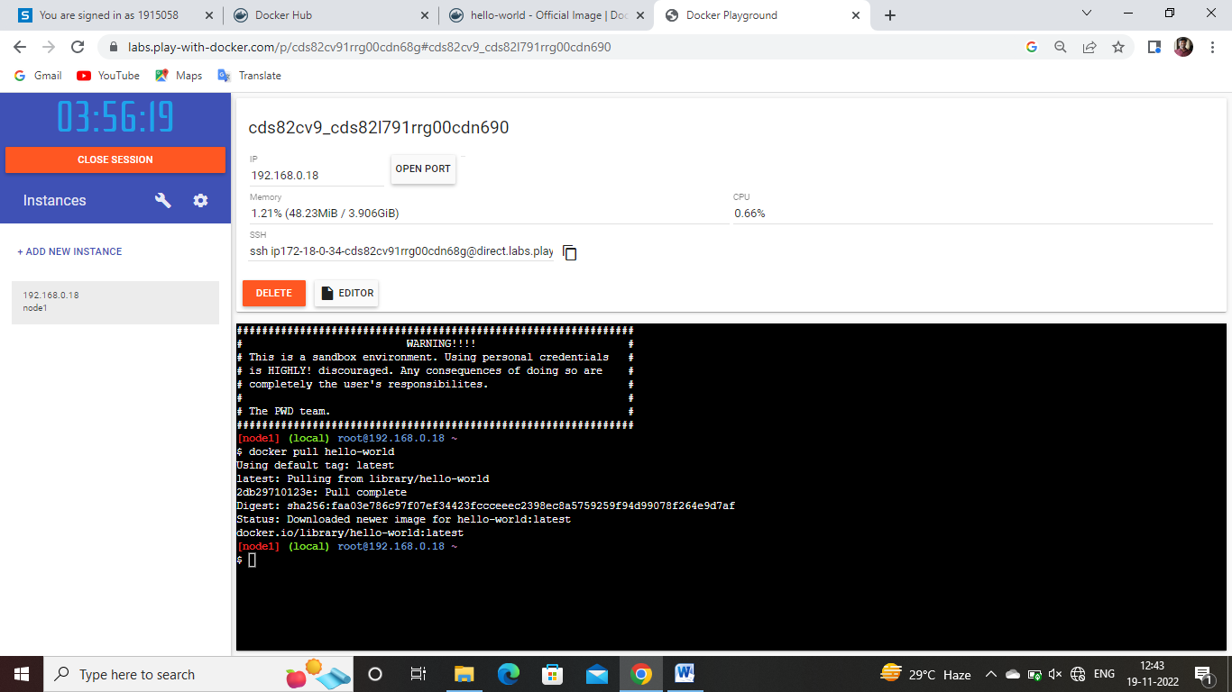

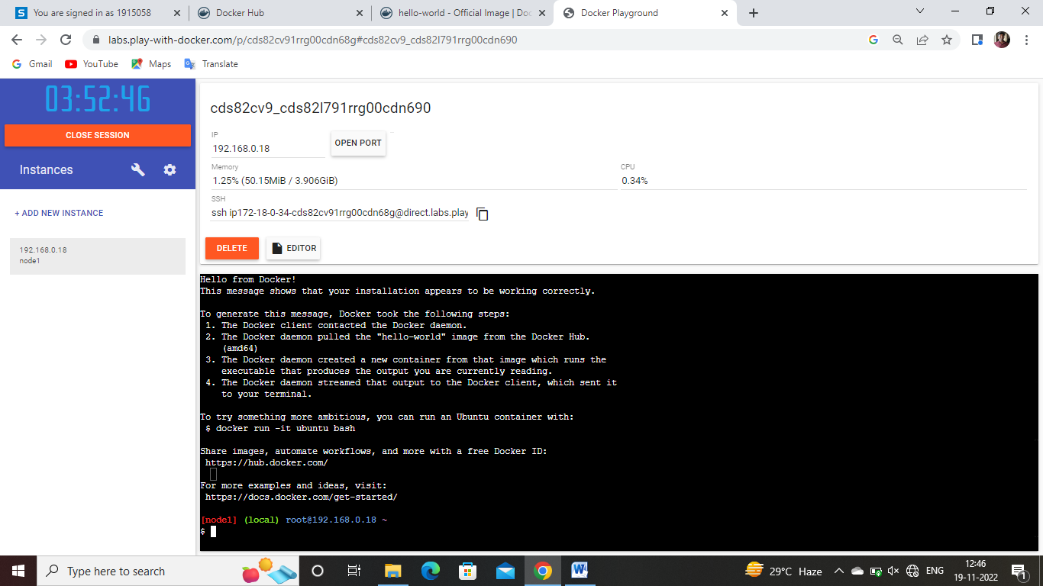

**2.Create a docker file for the jobportal application and deploy it in Docker desktop application.**

FROM python:3.10

WORKDIR /app

ADD . /app

COPY requirements.txt /app

RUN python -m pip install -r requirements.txt

RUN python -m pip install ibm_db

EXPOSE 5001

ENTRYPOINT [ "python" ]

CMD [ "app.py" ]

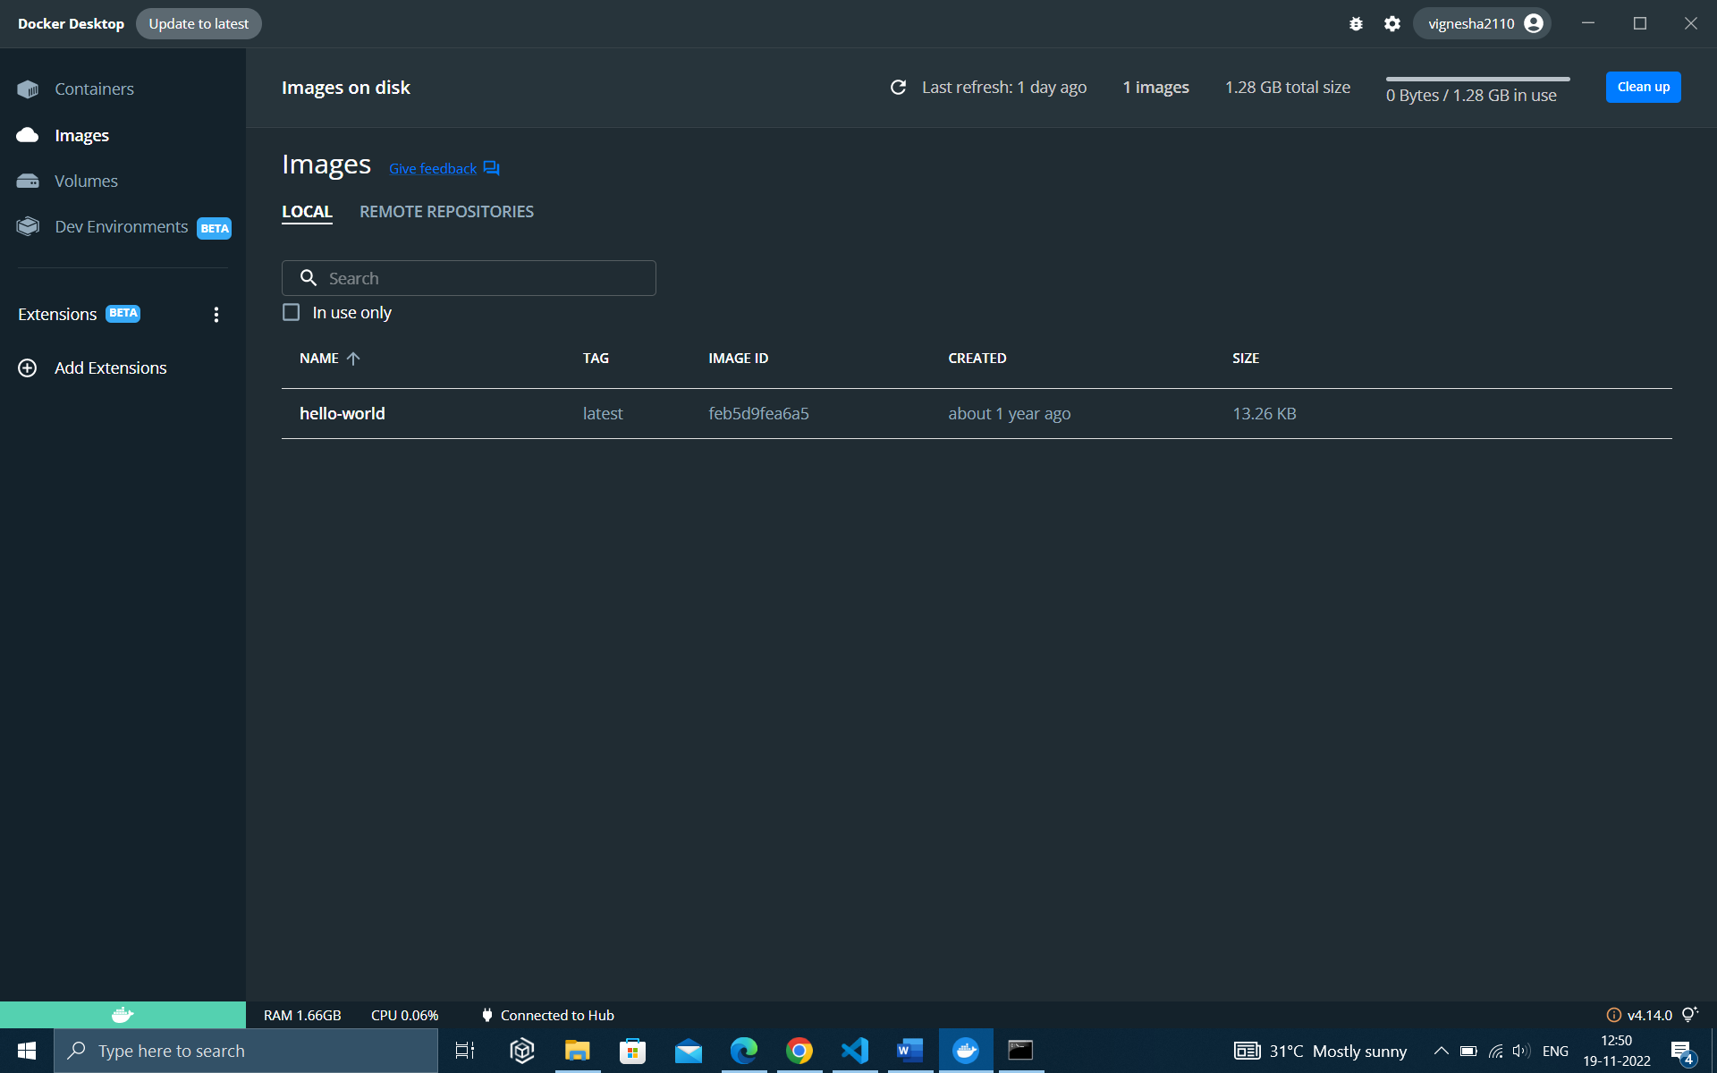

**3. Create a IBM container registry and deploy helloworld app or jobportalapp.**

